Physics is the combination of Matter (solid, liquid, gas and plasma – [it is the 4th state of matter. it is made of electron, ion and neutral atom. 97.8% -99.2% volume of the universe is in plasma]) and Energy (optics, heat...). Physics is the Experimental (Instrument, measurement and observation) Science
Heat
Heat is generated from the nuclear fusion in the Sun, and transported to earth as electromagnetic radiation, is one of the driving forces of life on Earth. Heat is energy transferred from one body, region, or thermodynamic system to another due to thermal contact when the systems are at different temperatures.

Definitions
- It is something which may be transferred from one body to another, according to the second law of thermodynamics.
- It is a measurable quantity, and thus treated mathematically
H or Q = m s Δθ (mass x Specific Heat x temperature difference).
- It cannot be treated as a substance, because it may be transformed into something that is not a substance, e.g., mechanical work.
- Heat is one of the forms of energy.
Several modern definitions of heat are as follows:
The energy transferred from a high-temperature system to a lower-temperature system is called heat. It flows spontaneously from one system to another caused by a difference in temperature.

Notation and units
As a form of energy heat has the unit joule (J) in the International System of Units (SI), (calorie Cal). However, in many applied fields in engineering the British Thermal Unit (BTU) and the calorie are often used. The standard unit for the rate of heat transferred is the watt (W), defined as joules per second.

Specific Heat: Amount of heat energy required to raise or to decrease unit temperature of an unit mass substance, i.e. s = Q/mΔθ = Q/m(θ₂ -θ₁) J/kg.K; cal/gm.⁰C

Temperature:
Temperature is a measure of effect of heat energy. It tells us about the degree of hotness or coldness of a body. Increase in volume, change in specific resistance, emission of electro magnetic waves (like Light) are the general effects of the temperature. Based on these principles temperatures are measured.
Principles of Temperature Measurement
Change in volume --- Liquid thermometers – Mercury/Alcohol thermometers
Change in resistance --- Resistance thermometers ---- digital thermometers
Emission of E/M waves --- Radiation thermometers --- Pyrometer

Comparison of Temperature Scales

Name of the Scales: (i) Kelvin K (ii) Celsius °C (iii) Fahrenheit °F (iv) Rømer°Rø (°R) ¹

Absolute Zero: Zero of thermodynamic temperature (0 Kelvin) and the lowest temperature theoretically attainable. It is the temperature at which the kinetic energy of atoms and molecules is minimal. It is equivalent to -273.15 ⁰C.
Comparison of temperature scales
Comment | Kelvin  K | Celsius  °C | Fahrenheit  °F | Rømer  °Rø (°R) ¹
Absolute zero | 0 | −273.15 | −459.67 | −135.90
Lowest recorded natural temperature on Earth  (Vostok, Antarctica - 21 July 1983) | 184 | −89 | −128 | −39
Celsius / Fahrenheit's "cross-over" temperature | 233.15 | −40 | –40 | –13.5
Fahrenheit's ice/salt mixture | 255.37 | −17.78 | 0 | −1.83
Water freezes (at standard pressure) | 273.15 | 0 | 32 | 7.5
Average surface temperature on Earth | 288 | 15 | 59 | 15
Average human body temperature ² | 310.0 ±0.7 | 36.8 ±0.7 | 98.2 ±1.3 | 26.8 ±0.4
Highest recorded surface temperature on Earth  (Al 'Aziziyah, Libya - 13 September 1922)  But that reading is queried. | 331 | 58 | 136 | 38
Water boils (at standard pressure) | 373 | 100 | 212 | 60
Gas flame | ~1773 | ~1500 | ~2732
Titanium melts | 1941 | 1668 | 3034 | 883
The surface of the Sun | 5800 | 5526 | 9980 | 2909

Heat and Thermodynamics Flow Chart

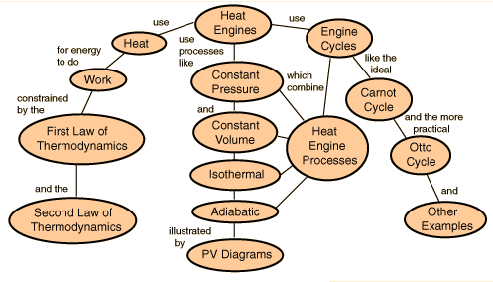

Resistance Thermometer: (Platinum)
Resistance thermometers, also called resistance temperature detectors or resistive thermal devices (RTDs), are temperature sensors that exploit the predictable change in electrical resistance of some materials with changing temperature. As they are almost invariably made of platinum, they are often called platinum resistance thermometers (PRTs). They are usedupto600 °C, due to higher accuracy and repeatability.

Construction
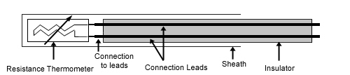
These elements nearly always require insulated leads attached. At temperatures below about 250 °C PVC, silicon rubber or PTFE insulators are used. Above this, glass fibre or ceramic are used.

Calculations
Resistance thermometer elements can be supplied which function up to 1000 °C. The relation between temperature and resistance is given by the Callendar-Van Dusen equation,
Here, R_{T} is the resistance at temperature T, R₀ is the resistance at 0 °C, and the constants (for an alpha=0.00385 platinum RTD) are
Since the B and C coefficients are relatively small, the resistance changes almost linearly with the temperature.

Internal energy and enthalpy
In the case where the number of particles in the system is constant, the first law of thermodynamics states that the differential change in internal energydU of a system is given by the differential heat flow δQ into the system minus the differential workδW exerted by the system:
,
The differential transfer of heat, δQ_{in}, makes differential contributions, not only to internal energy, but also to the work done by the system:
,
The work done by the system includes boundary work, which causes the boundaries of the system to expand, in addition to other work (e.g. shaft work performed by a compressor fan):
,
= (dH) of the system. Both enthalpy, H, and internal energy, U, are state functions. In cyclical processes, such as the operation of a heat engine, state functions return to their initial values. Substitution gives:,

Latent Heat
Latent energy as the energy of interaction in a given configuration of particles, i.e. a form of potential energy, and the sensible heat as an energy affecting the thermal energy, which he called the living force. Latent Heat, l_{f} = H or Q / m J/Kg or cal/gm
Latent heat is the heat released or absorbed by a chemical substance or a thermodynamic system during a change of state that occurs without a change in temperature. Such a process may be a phase transition, such as the melting of ice or the boiling of water.

Specific Heat
Specific heat, also called specific heat capacity, is defined as the amount of energy that has to be transferred to or from one unit of mass (kilogram) or amount of substance (mole) to change the system temperature by one degree. Specific heat is a physical property, which means that it depends on the substance under consideration and its state as specified by its properties.
Specific Heat, c = H or Q / m (θ₂ - θ₁) cal/gm/K or J/Kg/K
The specific heats of monatomic gases (e.g., helium) are nearly constant with temperature. Diatomic gases such as hydrogen display some temperature dependence, and triatomic gases (e.g., carbon dioxide) still more.

Entropy
In the mechanical theory of heat (thermodynamics): "if two transformations which, without necessitating any other permanent change, can mutually replace one another, be called equivalent, then the generations of the quantity of heat Q from work at the temperature T, has the equivalence-value:" entropy is defined as,S = Q / T J/K, and hence change of entropy
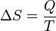
and thus, by reduction, quantities of heat δQ (an inexact differential) are defined as quantities of TdS (an exact differential):

To be precise, this equality is only valid, if the heat δQ is applied reversibly. If, in contrast, irreversible processes are involved, e.g. some sort of friction, then instead of the above equation one has
This is the second law of thermodynamics.
Zeroth Law of Thermodynamics
The Zeroth Law of Thermodynamics states that if two bodies are each in thermal equilibrium with some third body, then they are also in equilibrium with each other.  Thermal equilibrium means that when two bodies are brought into contact with each other and separated by a barrier that is permeable to heat, there will be no transfer of heat from one to the other. | 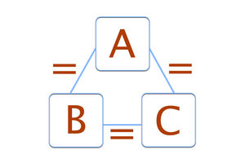

Constant Volume Gas Thermometer

Introduction: Thermometers are working examples of the zeroth law of thermodynamics. The significance of constant volume gas thermometers is that they are used to calibrate other thermometers.
Construction: A constant volume gas thermometer is composed of a bulb filled with a fixed amount of a dilute gas that is attached to a mercury manometer. A manometer is a device used to measure pressure. The mercury manometer has a column partially filled with mercury that is connected to a flexible tube that has another partially filled column of mercury, called a reservoir, attached to the other end.
The height of the mercury in the first column is set to a reference point or pressure P that it must stay at, while the mercury in the reservoir is allowed to move up and down in relation to a scale or ruler.The From the Law of Gay-Lussac, we know that when the temperature of an ideal gas increases, that there is a corresponding increase in pressure. Conversely, when the temperature decreases, so does the pressure. Constant volume gas thermometers operate on the same principle, with the restrictions that the gas is at low pressure and the temperature of it is well above that of liquefaction.

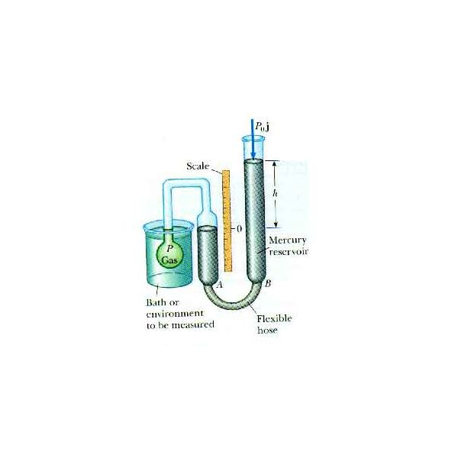
Fig. 1 Constant Volume
Thermometer

To recall, 273.16 K (Kelvin) is the temperature where water exists in an equilibrium state as a gas, liquid, and solid. For equation 1, where a = 273.16 K, b = 0, P_{tp} is the pressure of the gas at the triple point of water, and P is the pressure of the gas at the temperature to be measured, we have, 2) T = 273.16 K (P/P_{tp}). For low pressure and high temperatures, where real gases behave like ideal gases, equation 1 becomes:
3) T = 273.16 K lim P/P_{tp} as P_{tp} → 0

Calculations : For a pressure P, the equation used to find the temperature T is, 1) T = aP + b, where a and b are constants determined from two fixed points, such as ice at 0ºC and steam at 100ºC.As mentioned previously, the constant volume gas thermometer uses values from the triple point of water to calibrate other thermometers.

Operation: The gas bulb is inserted into a bath or place we wish to find the temperature of, such as water. When the temperature increases or decreases, the volume also increases or decreases as well as the pressure, as we have seen in Charles' Law and the aforementioned Gay-Lussac's Law. The pressure of the mercury also changes such that it begins to move up or down and thus away from the reference 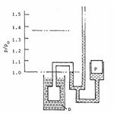
point. To stop this movement, which will also stop the gas from expanding, the reservoir at the other end is physically lifted up or down, and the ensuing new pressure at this height is measured. The difference between the reference and reservoir heights gives the final pressure P, which is then used to calculate the temperature.

Fig. 2 shows an example from Henry Sostmann's Fundamentals of Thermometry text. A helium filled bulb is placed into a water and steam bath that is at 100ºC. The mercury at the reference point is 1 Pa (Pascal), while that of the reservoir is at approximately 1.367 Pa. The difference between these two is used to help calculate the temperature of the bath.

First Law of Thermodynamics
The first law of thermodynamics is the application of the conservation of energy principle to heat and thermodynamic processes:
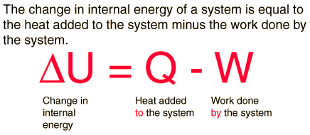
The first law makes use of the key concepts of internal energy, heat, and system work. It is used extensively in the discussion of heat engines. The standard unit for all these quantities would be the joule, although they are sometimes expressed in calories or BTU.
It is typical for chemistry texts to write the first law as ΔU=Q+W. It is the same law, of course - the thermodynamic expression of the conservation of energy principle. It is just that W is defined as the work done on the system instead of work done by the system. In the context of physics, the common scenario is one of adding heat to a volume of gas and using the expansion of that gas to do work, as in the pushing down of a piston in an internal combustion engine. In the context of chemical reactions and process, it may be more common to deal with situations where work is done on the system rather than by it.

Enthalpy
Four quantities called "thermodynamic potentials" are useful in the chemical thermodynamics of reactions and non-cyclic processes. They are internal energy, the enthalpy, the Helmholtz free energy and the Gibbs free energy. Enthalpy is defined by
H = U + PV
where P and V are the pressure and volume, and U is internal energy. Enthalpy is then a precisely measurable state variable, since it is defined in terms of three other precisely definable state variables. It is somewhat parallel to the first law of thermodynamics for a constant pressure system
Q = ΔU + PΔV since in this case Q=ΔH
It is a useful quantity for tracking chemical reactions. If as a result of an exothermic reaction some energy is released to a system, it has to show up in some measurable form in terms of the state variables. An increase in the enthalpy H = U + PV might be associated with an increase in internal energy which could be measured by calorimetry, or with work done by the system, or a combination of the two.
The internal energy U might be thought of as the energy required to create a system in the absence of changes in temperature or volume. But if the process changes the volume, as in a chemical reaction which produces a gaseous product, then work must be done to produce the change in volume. For a constant pressure process the work you must do to produce a volume change ΔV is PΔV. Then the term PV can be interpreted as the work you must do to "create room" for the system if you presume it started at zero volume.

The second law of thermodynamics may be expressed in many specific ways

Clausius statement:German scientist Rudolf Clausius is credited with the first formulation of the second law, now known as the Clausius statement:
No process is possible whose sole result is the transfer of heat from a body of lower temperature to a body of higher temperature.
Spontaneously, heat cannot flow from cold regions to hot regions without external work being performed on the system, which is evident from ordinary experience of refrigeration, for example. In a refrigerator, heat flows from cold to hot, but only when forced by an external agent, a compressor.

Kelvin statement
Lord Kelvin expressed the second law in another form. The Kelvin statement expresses it as follows: No process is possible in which the sole result is the absorption of heat from a reservoir and its complete conversion into work.
This means it is impossible to extract energy by heat from a high-temperature energy source and then convert all of the energy into work. At least some of the energy must be passed on to heat a low-temperature energy sink. Thus, a heat engine with 100% efficiency is thermodynamically impossible. Note that it is possible to convert heat completely into work, such as the isothermal expansion of ideal gas.

Application of second law of thermodynamics: Refrigerator
If we place our hand behind an operating refrigerator, you will notice that this area is warmer than the room temperature. Or you may notice that the refrigerator blows warm air on your feet as you stand in front of it. Yet the interior of the freezing compartment is very cold! The refrigerator is taking energy from the freezing compartment, making it colder, and exhausting that heat to the room, making it warmer. A refrigerator is a heat engine in which work is done on a refrigerant substance in order to collect energy from a cold region and exhaust it in a higher temperature region, thereby further cooling the cold region. This is shown in the following figure
Refrigerators have made use of CFC or fluorinated hydrocarbons with trade names like Freon-12, Freon-22, etc. which can be forced to evaporate and then condense by successively lowering and raising the pressure. They can therefore "pump" energy from a cold region to a hotter region by extracting the heat of vaporization from the cold region and dumping it in the hotter region outside the refrigerator. The statements about refrigerators apply to air conditioners and heat pumps, which embody the same principles.

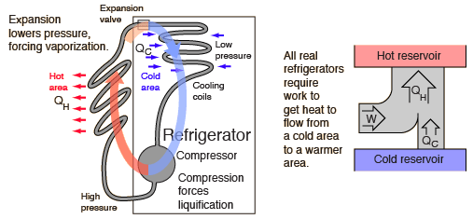

Entropy
According to the Clausius equality, for a reversible process
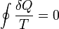
That means the line integral 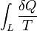is path independent.
So we can define a state function S called entropy, which satisfies
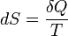
With this we can only obtain the difference of entropy by integrating the above formula. To obtain the absolute value, we need the Third Law of Thermodynamics, which states that S=0 at absolute zero for perfect crystals.
For any irreversible process, since entropy is a state function, we can always connect the initial and terminal status with an imaginary reversible process and integrating on that path to calculate the difference in entropy.
Now reverse the reversible process and combine it with the said irreversible process. Applying Clausius inequality on this loop,
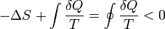
Thus,
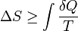
where the equality holds if the transformation is reversible.
Notice that if the process is an adiabatic process, then δQ = 0, so .

Statement of the Third Law of Thermodynamics
The third law states that as the temperature of a system approaches absolute zero, its entropy becomes constant, or the change in entropy is zero.
i. e. Lim ΔS = 0
T → 0

Carnot Cycle

The most efficient heat engine cycle is the Carnot cycle, consisting of two isothermal processes and two adiabatic processes. The Carnot cycle can be thought of as the most efficient heat engine cycle allowed by physical laws. When the second law of thermodynamics states that not all the supplied heat in a heat engine can be used to do work, the Carnot efficiency sets the limiting value on the fraction of the heat which can be so used. The conceptual value of the Carnot cycle is that it establishes the maximum possible efficiency for an engine cycle operating between T_{H} and T_{C}. It is not a practical engine cycle because the heat transfer into the engine in the isothermal process is too slow to be of practical value. As Schroeder puts it "So don't bother installing a Carnot engine in your car; while it would increase your gas mileage, you would be passed on the highway by pedestrians.”

Entropy and the Carnot Cycle
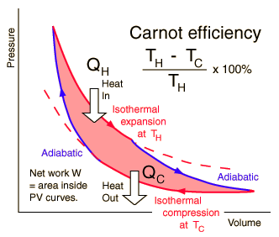 | The efficiency of a heat engine cycle is given by  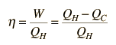  For the ideal case of the Carnot cycle, this efficiency can be written  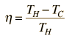
Using these two expressions together

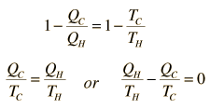
If we take Q to represent heat added to the system, then heat taken from the system will have a negative value. For the Carnot cycle
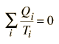

which can be generalized as an integral around a reversible cycle.

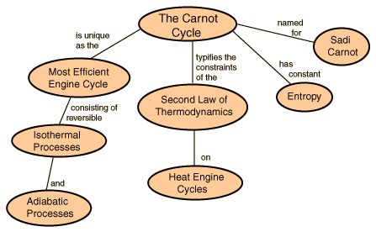

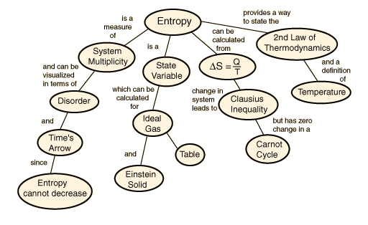

Kinetic theory
The temperature of an ideal monatomicgas is a measure of the average kinetic energy of its atoms. The atoms have a certain, average speed, slowed down here two trillion fold from room temperature.
The kinetic theory of gases describes a gas as a large number of small particles (atoms or molecules), all of which are in constant, randommotion. The rapidly moving particles constantly collide with each other and with the walls of the container. Kinetic theory explains macroscopic properties of gases, such as pressure, temperature, or volume, by considering their molecular composition and motion. Essentially, the theory posits that pressure is due not to static repulsion between molecules, as was Isaac Newton's conjecture, but due to collisions between molecules moving at different velocities.
While the particles making up a gas are too small to be visible, the jittering motion of pollen grains or dust particles which can be seen under a microscope, known as Brownian motion, results directly from collisions between the particle and gas molecules. As pointed out by Albert Einstein in 1905, this experimental evidence for kinetic theory is generally seen as having confirmed the existence of atoms and molecules. (W = F.d = P A.d = PV)

Postulates
The theory for ideal gases makes the following assumptions:
- The gas consists of very small particles. This smallness of their size is such that the total volume of the individual gas molecules added up is negligible compared to the volume of the container. This is equivalent to stating that the average distance separating the gas particles is large compared to their size.
- These particles have the same mass.
- The number of molecules is so large that statistical treatment can be applied.
- These molecules are in constant, random and rapid motion.
- The rapidly moving particles constantly collide among themselves and with the walls of the container. All these collisions are perfectly elastic. This means, the molecules are considered to be perfectly spherical in shape, and elastic in nature.
- Except during collisions, the interactions among molecules are negligible. (That is, they exert no forces on one another.)
This implies:
1. Relativistic effects are negligible.
2. Quantum-mechanical effects are negligible. This means that the inter-particle distance is much larger than the thermal de Broglie wavelength and the molecules are treated as classicalobjects.
3. Because of the above two, their dynamics can be treated classically. This means, the equations of motion of the molecules are time-reversible.
- The average kinetic energy of the gas particles depends only on the temperature of the system.
- The time during collision of molecule with the container's wall is negligible as compared to the time between successive collisions.
More modern developments relax these assumptions and are based on the Boltzmann equation. These can accurately describe the properties of dense gases, because they include the volume of the molecules. The necessary assumptions are the absence of quantum effects, molecular chaos and small gradients in bulk properties. Expansions to higher orders in the density are known as virial expansions. The definitive work is the book by Chapman and Enskog but there have been many modern developments and there is an alternative approach developed by Grad based on moment expansions.^{[citation needed]} In the other limit, for extremely rarefied gases, the gradients in bulk properties are not small compared to the mean free paths. This is known as the Knudsen regime and expansions can be performed in the Knudsen number.

Properties

Pressure and kinetic energy
Pressure is explained by kinetic theory as arising from the force exerted by molecules or atoms impacting on the walls of a container. Consider a gas of N molecules, each of mass m, enclosed in a cuboidal container of volume V=L³. When a gas molecule collides with the wall of the container perpendicular to the x coordinate axis and bounces off in the opposite direction with the same speed (an elastic collision), then the momentum lost by the particle and gained by the wall is: {mv_{x} – (-mv_{x})}
where v_{x} is the x-component of the initial velocity of the particle.
The particle impacts one specific side wall once every (v = d/t)
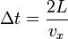
(where L is the distance between opposite walls).
The force due to this particle is:
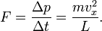

The total force on the wall is
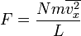
where the bar denotes an average over the N particles. Since the assumption is that the particles move in random directions, we will have to conclude that if we divide the velocity vectors of all particles in three mutually perpendicular directions, the average value along each direction must be same. (This does not mean that each particle always travel in 45 degrees to the coordinate axes.)
.
We can rewrite the force as
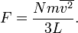
This force is exerted on an area L². Therefore the pressure of the gas is (F = PA)
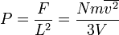
where V=L³ is the volume of the box. The fraction n=N/V is the number density of the gas (the mass density ρ=nm is less convenient for theoretical derivations on atomic level). Using n, we can rewrite the pressure as
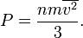
This is a first non-trivial result of the kinetic theory because it relates pressure, a macroscopic property, to the average (translational) kinetic energy per molecule 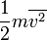which is a microscopic property.

Temperature and kinetic energy
From the ideal gas law
(1)
where is the Boltzmann constant, and the absolute temperature,
and from the above result 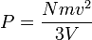we have 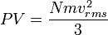
we have 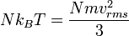
then the temperature takes the form
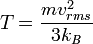 | (2)
which leads to the expression of the kinetic energy of a molecule
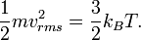
The kinetic energy of the system is N times that of a molecule 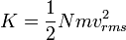
The temperature becomes
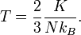 | (3)
Eq.(3)₁ is one important result of the kinetic theory: The average molecular kinetic energy is proportional to the absolute temperature. From Eq.(1) and Eq.(3)₁, we have
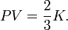 | (4)
Thus, the product of pressure and volume per mole is proportional to the average (translational) molecular kinetic energy.
Eq.(1) and Eq.(4) are called the "classical results", which could also be derived from statistical mechanics; for more details, see .^{[1]}
Since there are degrees of freedom in a monoatomic-gas system with particles, the kinetic energy per degree of freedom per molecule is
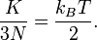 | (5)
In the kinetic energy per degree of freedom, the constant of proportionality of temperature is 1/2 times Boltzmann constant. In addition to this, the temperature will decrease when the pressure drops to a certain point. This result is related to the equipartition theorem.
As noted in the article on heat capacity, diatomic gases should have 7 degrees of freedom, but the lighter gases act as if they have only 5.
Thus the kinetic energy per kelvin (monatomic ideal gas) is:
- per mole: 12.47 J
- per molecule: 20.7 yJ = 129 μeV.
At standard temperature (273.15 K), we get:
- per mole: 3406 J
- per molecule: 5.65 zJ = 35.2 meV.

Collisions with container
One can calculate the number of atomic or molecular collisions with a wall of a container per unit area per unit time.
Assuming an ideal gas, a derivation^{[2]} results in an equation for total number of collisions per unit time per area:
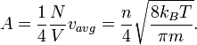

Speed of molecules
From the kinetic energy formula it can be shown that
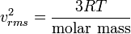
with v in m/s, T in kelvins, and R is the gas constant. The molar mass is given as kg/mol. The most probable speed is 81.6% of the rms speed, and the mean speeds 92.1% (distribution of speeds
Three postulates of the Kinetic Theory
- Gases consist of particles (atoms or molecules) in continuous, random motion.
- Collisions between gas particles are elastic.
- The average energy of translational motion of a gas particle is directly proportional to temperature.
In addition to the postulates above, it is assumed that the volumes of the particles are negligible as compared to container volume and attractive forces between particles are neglected.
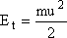
E_{t} = average kinetic energy of translation
KE_{avg}
m = mass of the particle
u = average velocity of the particle
from the third postulate we can formulate
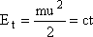
T = temperature in Kelvin, c = constant which has the same value for all gases.
- Average Speed of Gas particles (find u)
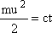
c = constant = 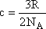
R = gas constant, N_{A} = Avogadro's #
substituting for c
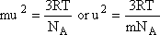
mass times moles (N_{A}) equals Molar Mass (MM), substituting MM and solving for u gives
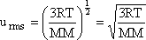
using this last equation we can solve for an individual gas particle's speed rms = root mean square, which is the average square root of the speed of the individual particles.
Use R = 8.3148 , in order for the units to come out in m/s
- Grahm's Law
effusion - the flow of gas particles through a small opening or pinhole in a container.
diffusion - random motion of gas particles.
formulas:
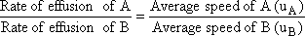
if the two gases are at the same temperature then:
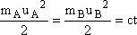
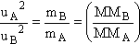
Experimentally usually measure the time for effusion to occur, this time is an inverse of the effusion rate (lower times-faster effusion rates)
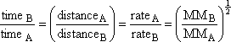
this equation was used for the separation of U₂₃₈ during WWII by effusion principles.
Real Gases
Deviate at least slightly from Ideal Gas Law because of two factors:
- gas molecules attract one another
- gas molecules occupy a finite volume
Both of these factors are neglected in the Ideal Gas law. Both increase in importance when molecules are close together (high P, low T)
van der Walls equation
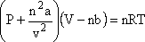
corrects for the attraction between molecules.
nb corrects for the volume of gas molecules

System Work
When work is done by a thermodynamic system, it is usually a gas that is doing the work. The work done by a gas at constant pressure is:
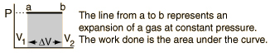
For non-constant pressure, the work can be visualized as the area under the pressure-volume curve which represents the process taking place. The more general expression for work done is:
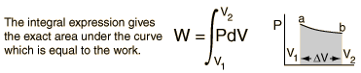
Work done by a system decreases the internal energy of the system, as indicated in the First Law of Thermodynamics. System work is a major focus in the discussion of heat engines.

